**AZURE AVIATION**

...catering to your wings

Make your flying dreams come true with Azure Aviation! Here’s presenting to you an easy and effective way of booking airline tickets! Azure aviation allows you to book tickets, cancel tickets and check in to your flight efficiently with utmost convenience.

The airline Reservation system brought to you by Azure Aviation works at 3 levels:

1. Booking
2. Cancelation
3. Check in

**Booking:**

In this level, details such as origin, destination, departure date, number of passengers (whether passenger is student/non-student) will be input by the user. The flights along with departure time, flight number and cost will be displayed on the screen. A 20% discount shall be given as a student discount. The next step involves entering personal information such as name, mobile number, Email ID, and age of passenger. Type of seat can be chosen according to the person’s desire (economy, business, first class). We provide a complimentary meal for our dear customers which can be chosen during booking. The customer proceeds to pay the travel fare by net banking. A preview of the passenger’s ticket will be displayed on the screen.

**Cancelation:**

By entering details such as name, email, PNR number and flight number an immediate flight cancelation can be made with a cancellation fee of Rs 500. The balance amount will be refunded to the customer’s respective back account.

**Check in:**

Passengers are required to check in to their flight 48 to 2hrs prior to take off.

This can be done by entering details such as PNR number, flight number, name, email address of the passenger.

**Working:**

All the necessary data such as flight number, origin and destination locations and prices are preloaded in the back-end MySQL database. When the customer enters the necessary details such as name, email ID, Age, gender, and choice of complimentary meal in the front-end Python, the program searches for the most suitable flight options and displays it on the screen for the customer to choose from. All the data provided by the customer will be stored. After the process of payment, all the details will be previewed as an Airline ticket on the screen for the customer.

**Conclusion:**

All in all, by using a Graphical User Interface module (tkinter) in python along with MySQL-connector a simple but elegant airline ticket reservation system has been devised.

Thank you for flying with Azure Aviation! Happy Flying!

**Software information:**

**Front end:** Python

**Back end:** MySQL database system

**Modules used:** Tkinter, MySQL connector, Prettytable, tkcalendar, pyqrcode, datetime, colorama, random

BY:

Sunil Thunga (42)

Yashasvi Jana (47)

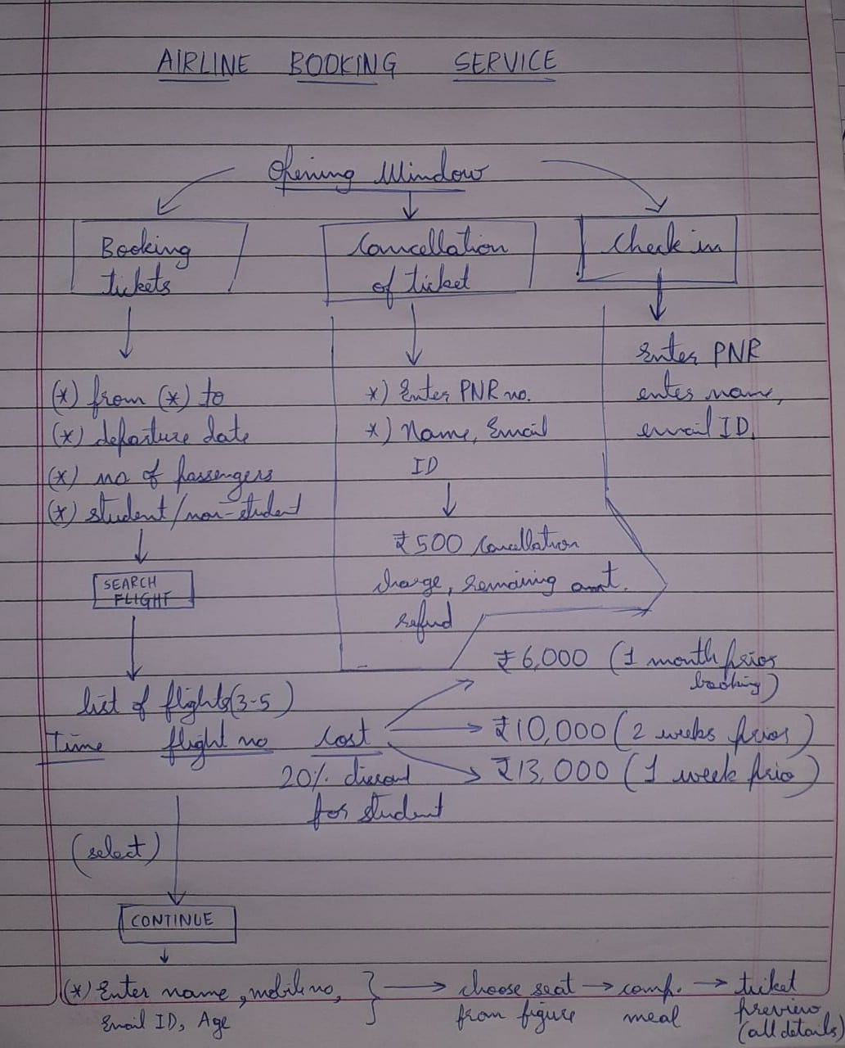

BY:

Sunil Thunga (42)

Yashasvi Jana (47)